# Safety Warnings

THE MICRO:BIT IS AN EXPOSED BOARD, TO BE USED WITH CARE PLEASE RETAIN THIS INFORMATION FOR FUTURE REFERENCE. You can read the detailed document at - <http://microbit.org/guide/safety-advice/>

# General Safety Warnings

Using the BBC micro:bit is easy to use but is designed to have all the electrical parts on display. This does mean there's a small risk that the parts can be damaged and even overheat with a risk of injury but a little bit of care and caution will ensure you and your micro:bit will stay fit and healthy.



1. Always keep your BBC micro:bit in the anti-static bag when not in use. It's good practice for students to earth themselves before handling it.
2. Please handle your BBC micro:bit by its edges. This minimises the risk of damage through an electrostatic discharge.
3. Please use the battery pack and the USB lead provided to power your micro:bit. Do not use portable battery chargers or USB charging ports (often marked with a lightning bolt or 'SS'), to power your micro:bit. Using these may damage your micro:bit and stop it working properly.
4. Please avoid handling the BBC micro:bit circuit board while plugged into a power supply.
5. All peripherals (for example: USB cable, battery holder, sensors) used with your BBC micro:bit should comply with the relevant standards and should be marked accordingly.
6. Connecting your BBC micro:bit to any unapproved peripherals could damage your BBC micro:bit
7. Please do not attempt to keep using faulty micro:bits. If a school-issued micro:bit develops a fault, contact the vendor immediately.
8. The maximum current safely supplied to an external circuit using the 3V pin on the edge connector is 100mA. Please make sure this limit is not exceeded.
9. Please do not store or use your BBC micro:bit in extremely hot or cold environments.
10. Do not place any metal objects across the printed circuits on the board as this can cause a short circuit damaging your BBC micro:bit. This can cause risk of burn or fire.
11. Do not use your BBC micro:bit in water or with wet hands.
12. Do not leave your BBC micro:bit plugged into a computer or any other device unsupervised.
13. Please do not leave your BBC micro:bit within reach of children under 8 years of age.
14. Please operate your BBC micro:bit in a well ventilated room To remove the battery pack, pinch the connector with your fingers. Do not remove by pulling the wires.

# Battery Warnings



1. Do not try to charge normal (non-rechargeable) batteries
2. Please do not mix different types of batteries or mix new and used batteries.
3. Please use batteries of the same or equivalent type as those recommended.
4. Please insert batteries the correct way round (with the correct polarity).
5. Please remove spent batteries from the battery holder.
6. Do not short-circuit the battery supply terminals, for example by placing a metal object across the terminals.
7. Only use Zinc or Alkaline batteries with your BBC micro:bit.
8. Please do not use rechargeable batteries

# Pre-requisites

If you need assistance with the assembly of the micro:bit, Edge connector breakout board, mounting board and the breadboard please speak to one of the volunteers on duty.

To be able to perform this tutorial you will need the following components –

1. Parts required –
   1. 1 x BBC Micro:bit
   2. 1 x Mounting Plate
   3. 1 x Edge connector breakout board
   4. 1 x Bread board
   5. 2 x LED
   6. 2 x 2.2K (2200) Ohm Resistor
   7. 3 x Male – Female Dupont wires
   8. 2 x Male – Male Dupont wires
2. Assembly required –
   1. Bread board mounted on top of the mounting plate
   2. BBC Micro:bit inserted into the Edge Connector breakout board

# C:\Perf\Personal\Github\CoderDojo\Images\Hi_Res_BBC_Microbit.jpg

Before proceeding please check your setup and confirm that all the required parts are configured as demonstrated in the above picture.

# Learning Objectives

The objectives of this tutorial are to explore and learn the basic concepts of electricity, circuits, LED’s including using code to turn an LED on and off. This tutorial builds upon concepts introduced in previous tutorials so please make sure you have covered the previous tutorials before you dive into this one.

Explore the following concepts through making –

1. Connecting elements in a circuit
2. Understanding the flow of current through the elements in the circuit
3. Understanding the concepts of voltage across different components in a circuit
4. Understanding the concept of elements connected in parallel in a circuit
5. Understand the approach to using code to create switches
6. Understand the approach to creating multiple switches and creating lighting patterns using LEDs

# Exploring components

If you haven’t been introduced to the following components it’s worth reading through this section –

1. Resistors
2. LED’s
3. NPN/PNP Bi-Junction Transistors or also called BJT’s

Let’s briefly look at what resistors and LED’s are all about before we dive into actually making the circuit.

# What Are Resistors

*“What is a resistor?” the student asked.  
“It’s a component that resists the flow of current” I said.  
“Hmm.. I don’t get it. What does it do to my circuit?” the student asked.  
“Well, it doesn’t actually do anything actively, all a resistor does is resists the flow of current through a given circuit” I said. Have a look at what the resistor might look like.*

Resistors are electronic components which have a specific, never-changing [electrical resistance](https://learn.sparkfun.com/voltage-current-resistance-and-ohms-law/resistance). The resistor’s resistance limits the flow of electrons through a circuit. They are passive components, meaning they only consume power (and can’t generate it). Resistors are usually added to circuits where they complement active components like op-amps, microcontrollers, and other [integrated circuits](https://learn.sparkfun.com/tutorials/integrated-circuits). Commonly resistors are used to limit current, [divide voltages](https://learn.sparkfun.com/tutorials/voltage-dividers), and [pull-up I/O lines](https://learn.sparkfun.com/tutorials/pull-up-resistors).



The schematic symbol used for resistors in circuits is –



# What Are LED’s

LEDs are so common, they come in dozens of different shapes and sizes. The LEDs you are most likely to use are the through hole LEDs with two legs. There are lots of LEDs that are small and hard to solder but these are easy to use with a breadboard because they have long wires we can stick in. The clear or clearish bulb is what protects the light emitter (that’s where the magic happens). In fact, the first two letters of LED stand for Light Emitting.

A really nice thing about LEDs is that they are very simple. Unlike some chips that have dozens of pins with names and special uses, LEDs have only two wires. One wire is the anode (positive) and another is the cathode (negative). The two wires have different names because LEDs only work in one direction and we need to keep track of which pin is which. One goes to the positive voltage and the other goes to the negative voltage. Electronic parts that only work in 'one direction' like this are called Diodes, that’s what the last letter of LED stands for.

[](https://learn.adafruit.com/assets/3890)

* The longer lead goes to the more-positive voltage
* Current goes in one direction, from the anode (positive) to the cathode (negative)
* LEDs that are 'backwards' won't work - but they won't break either

The schematic representation for LED’s in circuits is as follows –



It's all a little confusing - we often have to think about which is which. So to make it easy, there's only one thing you need to remember and that's the LED wont light up if you put it in backwards. If you're ever having LED problems where they are not lighting, just flip it around. Its very hard to damage an LED by putting it in backwards so don't be scared if you do



One of the best things about modern LEDs is all the colors they come in. It used to be that LEDs were only red or maybe yellow and orange, which is why early electronics from the 70s and 80s only had red LEDs. The color emitted from an LED has to do with what type of material they are made of. So red, for example, is made with Gallium Arsenide. Since then, scientists have experimented with many other materials and figured out how to make other colors such as green and blue, as well as violet and white.

# What Are Bi-Polar Junction Transistor or BJT’s

Transistors make our electronics world go ‘round. They’re critical as a control source in just about every modern circuit. Sometimes you see them, but more-often-than-not they’re hidden deep within the die of an integrated circuit. In this tutorial we’ll introduce you to the basics of the most common transistor around: the bi-polar junction transistor (BJT). In small, discrete quantities, transistors can be used to create simple electronic switches, digital logic, and signal amplifying circuits. In quantities of thousands, millions, and even billions, transistors are interconnected and embedded into tiny chips to create computer memories, microprocessors, and other complex ICs.



There are two types of basic transistor out there: bi-polar junction (BJT) and metal-oxide field-effect (MOSFET). In our tutorials we’ll focus on the BJT, because it’s slightly easier to understand and work with. Digging even deeper into transistor types, there are actually two versions of the BJT: NPN and PNP. We’ll turn our focus even sharper by limiting our early discussion to the NPN. By narrowing our focus down – getting a solid understanding of the NPN – it’ll be easier to understand the PNP (or MOSFETS, even) by comparing how it differs from the NPN.

Transistors are fundamentally three-terminal devices. On a bi-polar junction transistor (BJT), those pins are labelled collector (C), base (B), and emitter (E). The circuit symbols for both the NPN and PNP BJT are below:



The only difference between an NPN and PNP is the direction of the arrow on the emitter. The arrow on an NPN points out, and on the PNP it points in. Transistors are built by stacking three different layers of semiconductor material together. Some of those layers have extra electrons added to them (a process called “doping”), and others have electrons removed (doped with “holes” – the absence of electrons). A semiconductor material with extra electrons is called an n-type (n for negative because electrons have a negative charge) and a material with electrons removed is called a p-type (for positive). Transistors are created by either stacking an n on top of a p on top of an n, or p over n over p. See the diagram below -



Simplified diagram of the structure of an NPN. Notice the origin of any acronyms?



With some hand waving, we can say electrons can easily flow from n regions to p regions, as long as they have a little force (voltage) to push them. But flowing from a p region to an n region is really hard (requires a lot of voltage). But the special thing about a transistor – the part that makes our two-diode model obsolete – is the fact that electrons can easily flow from the p-type base to the n-type collector as long as the base-emitter junction is forward biased (meaning the base is at a higher voltage than the emitter).

The NPN transistor is designed to pass electrons from the emitter to the collector (so conventional current flows from collector to emitter). The emitter “emits” electrons into the base, which controls the number of electrons the emitter emits. Most of the electrons emitted are “collected” by the collector, which sends them along to the next part of the circuit. A PNP works in a same but opposite fashion. The base still controls current flow, but that current flows in the opposite direction – from emitter to collector. Instead of electrons, the emitter emits “holes” (a conceptual absence of electrons) which are collected by the collector.

The transistor is kind of like an electron valve. The base pin is like a handle you might adjust to allow more or less electrons to flow from emitter to collector.

# Activity

Before we get started, let’s make sure that all the required components are configured as required.

# Step 1 - Build

Let’s now connect up the relevant components on our micro:bit.

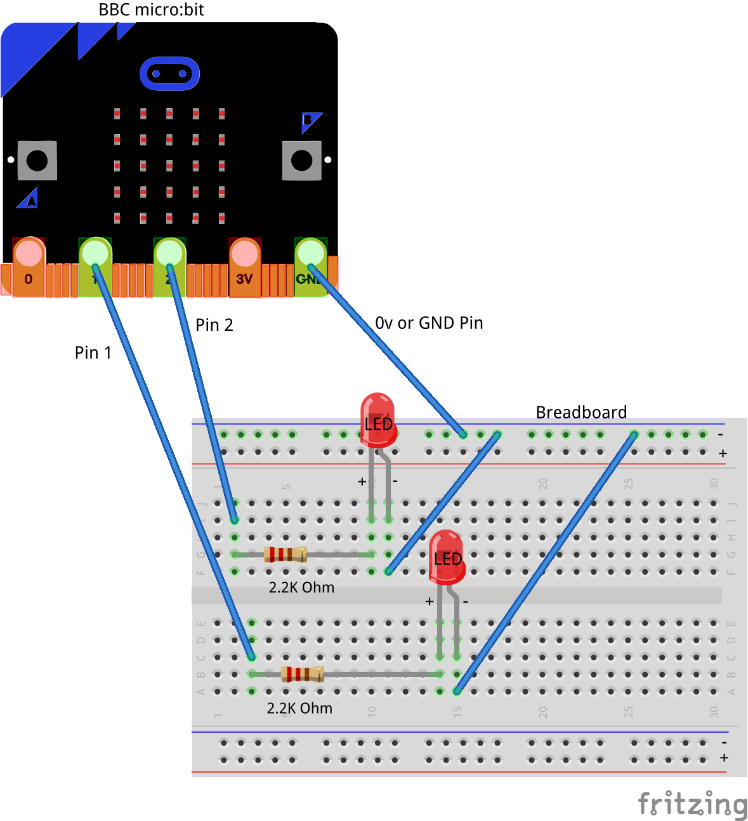

Please note that on the breadboard, between the horizontal blue and red lines all the holes are horizontally connected to each other. In the middle of the board however all the holes are vertically connected to each other. In in doubt please speak to a volunteer/mentor to clarify the approach. The main difference between the circuit in this tutorial and the previous one is the introduction of an additional LED and a 2.2K Ohm resistor.

The connections should be made as follows:

1. Connect the Male – Female Dupont wire from the Ground (0v) pin on the micro:bit (using the Edge Connector Breakout board) to the ground rail on the breadboard.
2. Connect a Male – Female Dupont wire from Pin2 pin on the micro:bit (using the Edge Connector Breakout board) to 2.2K Ohm resistor on the breadboard as shown
3. Connect the 2.2K Ohm resistor to the Anode (Positive, Large leg) of the LED. Use a Male to Male dupont cable if required.
4. Connect the Cathode (Negative, Shorter led) of the LED to the Ground (0v) using a Male to Male dupont cable.

Now let’s connect up the second pair of LEDs and resistor so as to be able setup two software switches.

1. Connect a Male – Female Dupont wire from Pin1 pin on the micro:bit (using the Edge Connector Breakout board) to 2.2K Ohm resistor on the breadboard as shown
2. Connect the second 2.2K Ohm resistor to the Anode (Positive, Large leg) of the LED. Use a Male to Male dupont cable if required.
3. Connect the Cathode (Negative, Shorter led) of the LED to the Ground (0v) using a Male to Male dupont cable.

This circuit you will note is very similar to the circuit we used for our series experiences i.e. 4a1, 4a2 and 4a3. The difference here is that we will be using code to turn the LED on and off. This simple circuit consists of two similar sets of components each comprising of, a 2.2K resistor and an LED. The 2.2K resistor is required to limit the current flowing through the LED and preventing the LED from burning up.

We will be extending the code written in the earlier tutorial and automate the turning on and off of the second LED. You can also play around with the timing and change the rate of blinking of the LEDs using code.

## Self-Assessment

* I have the breadboard mounted onto the mounting plate.
* I have the micro:bit plugged into the Edge connector breakout board.
* I understand each of the components in the circuit i.e. LED, resistor, Male – Female Dupont wires, etc.
* I have each of the elements in the circuit wired up using the breadboard
* I have checked the connections on the circuit and have not powered it on
* I understand how to use the male – male and male – female dupont cables to create connections using the breadboard
* I understand what the positive / 3v and ground / 0v rails (top and bottom) of the breadboard do and how they are connected
* I understand how the central rows in the breadboard are lined up together and how they are connected.
* I understand the difference between 3 Volt (3V) and Ground (0 Volt of 0V)

This now completes your circuit.

**PLEASE DO NOT POWER ON YOUR micro:bit UNLESS YOU HAVE HAD YOUR CIRCUIT VALIDATED BY A FACILITATOR/MENTOR/Volunteer.**

# Step 2 - Explore

Discuss the following concepts with the learning facilitator

1. Which components in this circuit are in series?
2. Are there any components in this circuit which are connected in parallel?
3. What are the paths for current flowing through this parallel circuit?
4. Which are passive and active components in a parallel circuit?

## Self-Assessment

* I can explain what a circuit means, what are components connected in series and components connected in parallel.
* I can explain the differences between active and passive components in circuits.
* I understand how components can be connected in series and parallel.
* I understand the use of the 2.2K resistor in the circuit to limit the current flowing into the base of the transistor

# Step 3 – Validate

Please call a facilitator to check your circuit before you power it on. It is important that you get a learning facilitator/mentor/volunteer to check the connections on your circuit before powering it on.

Incorrect connections might result in a dead (bricked, burnt, short-circuited, etc.) Micro:bit requiring you to purchase another Micro:bit for $30 AUD.

# Step 4 – Power On

Awesome, you are almost at the point where you can power on your circuit and watch the magic un-fold. Please call a facilitator to check your circuit before you power it on. It is important that you get a learning facilitator to check the connections on your circuit before powering it on.

Once the learning facilitator has verified your circuit you should now proceed and power on the Micro:bit. If you have not had your learning facilitator verify the circuit PLEASE GO BACK To step 3 and have one of the learning facilitators verify your connections.

Powering on the Micro:bit requires that you connect the USB power cord for your Micro:bit (plugged into the Micro:bit board) into your laptop.

Incorrect connections might result in a dead (bricked, burnt, short-circuited, etc.) Micro:bit requiring you to purchase another Micro:bit for $30 AUD.

## Self-Assessment

* I am able to wire the series circuit with all the elements shown
* I understand the flow of current through a series circuit
* I understand the difference between 3 Volt (3V) and Ground (0 Volt of 0V)
* I have validated that the circuit is now wired correctly and safe to be powered on

# Let’s write some code

Now that we have put together the circuit it’s time to write some code and get the circuit working. So let’s head over to the micro:bit block code editor page (<https://makecode.microbit.org/>) and get coding!!!

In the following section we will dive into the code you will put together for this tutorial –

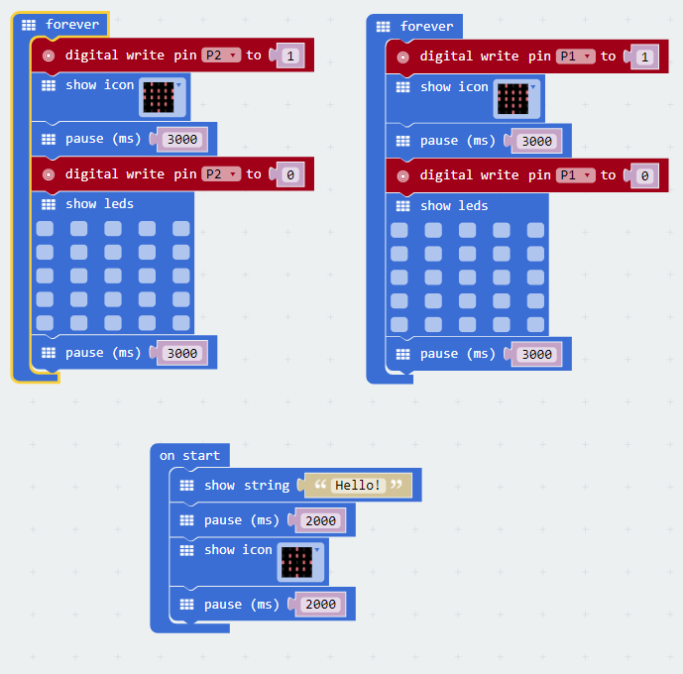

We will be extending the code written in the earlier tutorial and automate the turning on and off of the second LED. You can also play around with the timing and change the rate of blinking of the LEDs using code.

As mentioned before the aim of this tutorial is to create a software based switch i.e. writing commands in software and asking the micro:bit to turn the LED on and off. We will extend the code written in the previous tutorial and create two sets of software switches. Also by varying the “pause” time i.e. the amount of time we request the micro:bit to go to sleep we are able to create different types of lighting patterns.

The software based switch involves the use of the following command, “digitial write pin2” and “digitial write pin1”. In the digital world computers only understand 0’s and 1’s. So if we were to turn on a pin i.e. to send a signal and switch on a particular pin on the micro:bit you have to send it a 1 and if we intended to turn off a pin i.e. send it a signal and switch off a particular pin on the micro:bit you would send it a 0.

So let’s dive into the code and get started.

On start code block -

1. We display a welcome message to the user.
2. We pause for 2s. This essentially tells the micro:bit to go to sleep for 2s.
3. We then display a pattern using LED’s. You can change this to whatever you like.
4. Finally we have another set of pause commands so that people can appreciate the LED’s being lit up.
   * Not having the pause command will mean that the micro:bit (our little computer) still lights up the LED’s but does it so quickly that we just don’t get an opportunity to appreciate the work it’s done.
   * Similar to the work we’ve done in scratch we will inject pause statements (only where required) asking the computer to pause so that the human beings interacting with it can appreciate the transition from one mode of operation to another.
5. We finally pause a bit before continuing with rest of the code.

Forever code block –

1. The forever code block on the bbc micro:bit is designed to run code literally for ever. So any code you place within this block will run for ever.
2. The first line now includes the “digital write pin2” command we discussed a bit earlier to turn on the LED by sending it a 1
3. We then light up the LED’s and display a heart when nothing else is being displayed on the screen
4. The third line then pauses the code for 3 seconds. Just like in scratch the pause command is really important causes it gives the human beings time to see, understand and perceive what is happening. The computer doesn’t need any time as such and without the pause/sleep command it would have happily continued going about it’s business. The pause commands makes the transition from on to the off state visible to the individual working on the micro:bit.
5. The fourth line then uses the “digital write pin2” command again to turn the pin off by sending it a 0.
6. The fifth line clears up the LED’s and displays nothing on the screen giving it the illusion of the screen turning off creating a flashing on/off effect.
7. The sixth line of the simply pauses the entire code block for 3 seconds. Just like in scratch the pause command is really important causes it gives the human beings time to see, understand and perceive what is happening. The computer doesn’t need any time as such and without the pause/sleep command it would have happily continued going about it’s business. The pause commands makes the transition from on to the off state visible to the individual working on the micro:bit.

There are two sets of forever blocks in this code and you would have guessed that one code block allows us to switch on/off LED2 while the second allows us to switch on/off LED1. This program is a logical extension of the previous one and should give you an idea of how to scale out capability of your programs using the micro:bit code editor while also incorporating slightly more complex circuits.

# Downloading Your Code To The micro:bit

Once you have completed the program, enter a name for your program using the option provided below i.e. in the text box adjacent to the small save button.



Now that you have given your program a name and saved it you can download it your micro:bit. But before we do that let’s confirm what drive your micro:bit shows up as. On most machines the micro:bit will show up as an additional USB drive. So head over into windows explorer and confirm what drive name (D:, E:, F:. G:, etc. ) the micro:bit shows up as. You need to absolutely be sure what drive the micro:bit shows up as. Once you’ve confirmed what drive the micro:bit shows up as on your machine you can select the right drive when downloading the code to the micro:bit. If in doubt please ask the volunteer/mentor/session facilitator helping out.



To download the newly written code to the micro:bit, hit the download button shown above. You should now see a dialog box open up and you will be asked to save the file somewhere on your machine. Please choose the drive your micro:bit shows up as i.e. D: or E: or F: or whatever it shows up as on your machine. A sign of success is when you see the lights on the rear (orange) lighting up in quick succession suggesting that the code is being written to the micro:bit. On completion the micro:bit reboots and you should now see the code in action on the micro:bit.

If hitting the download button shown above does not open up a dialog box asking you to save to the micro:bit please save the file (you will have a <filename.hex> file) to your desktop. Then open up windows explorer and drag that file onto the drive which is your micro:bit. A sign of success is when you see the lights on the rear (orange) lighting up in quick succession suggesting that the code is being written to the micro:bit. On completion the micro:bit reboots and you should now see the code in action on the micro:bit.

Please feel free to customize the code blocks, have a play. Add your own custom code and re-download the code to the micro:bit. Give yourself a tap on the back, you’ve just completed your first circuit!!!!!

# Challenges

Well done for completing the Series Circuit tutorial. There’s a lot of ground we have covered in this tutorial so please feel free to make notes, come back to the tutorial at some point down the line and ask your learning facilitator any questions or doubts you might have on the concepts covered this far.

For those who want to stretch it a bit further -

1. Can you try changing the value of the pause commands to vary the time the LED’s are put to sleep?
2. Can you try different combinations of the pause commands to create an on/off lighting effect?
3. What if you want to add another set of LED, resistors into the circuit and create a third software switch?
4. What happens if you add another LED or more than a couple of LED’s in series with the first one?
5. What happens if you add a lower value resistor in parallel with the first resistor? How is the flow of current impacted?
6. What happens if you add a higher value resistor combined with the lower value resistor in series?
7. Can you write the code for the above circuit in python?